Show Bar chart

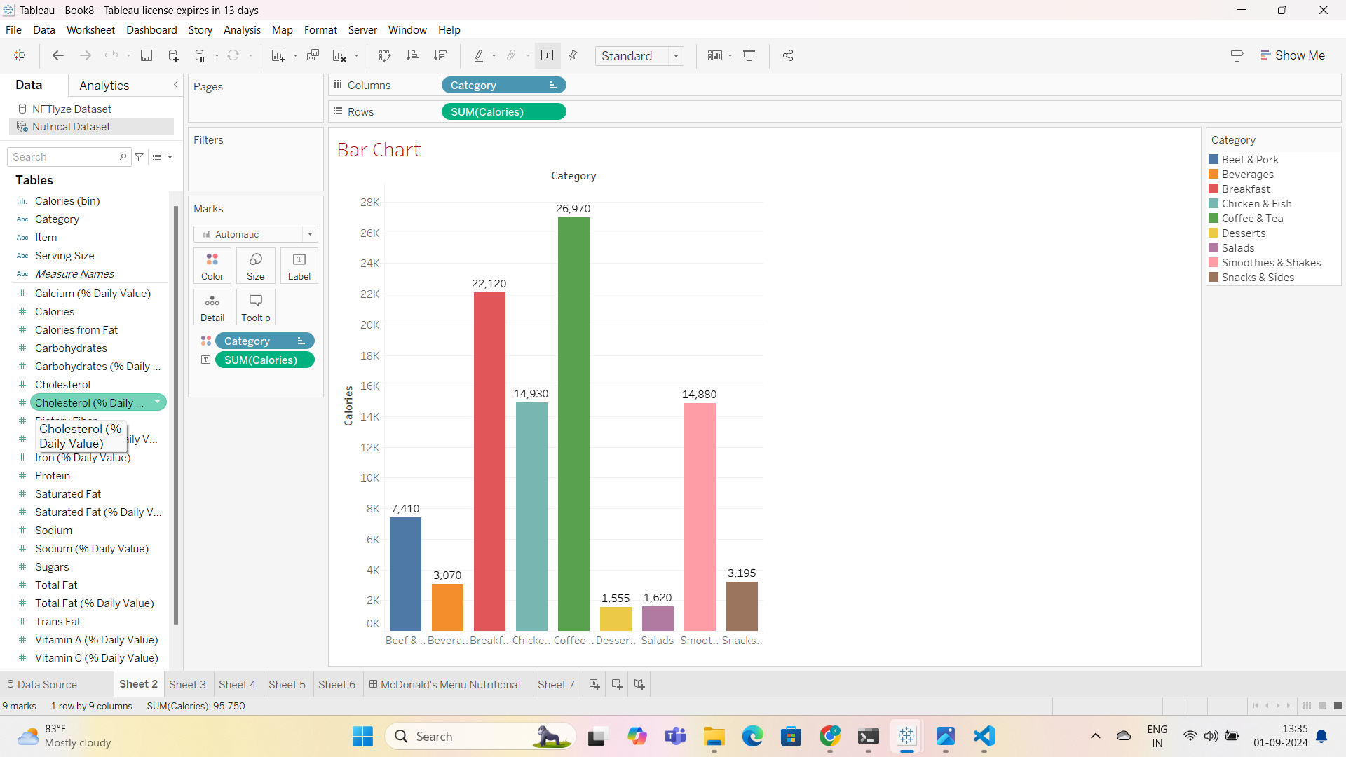

**Histograms (chart)**

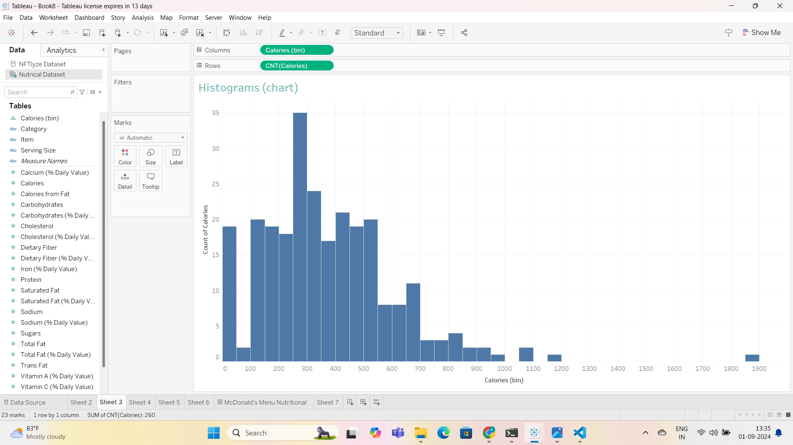

**Box Plot**

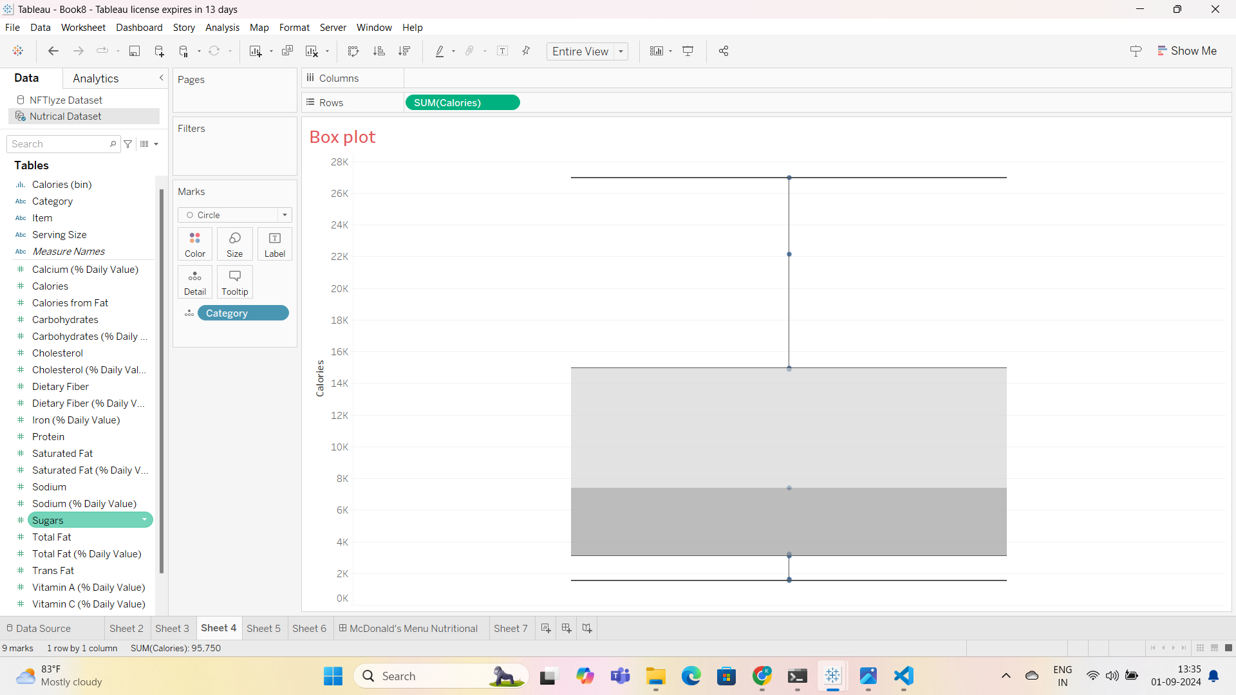

**Bar chart for Different Food Category**

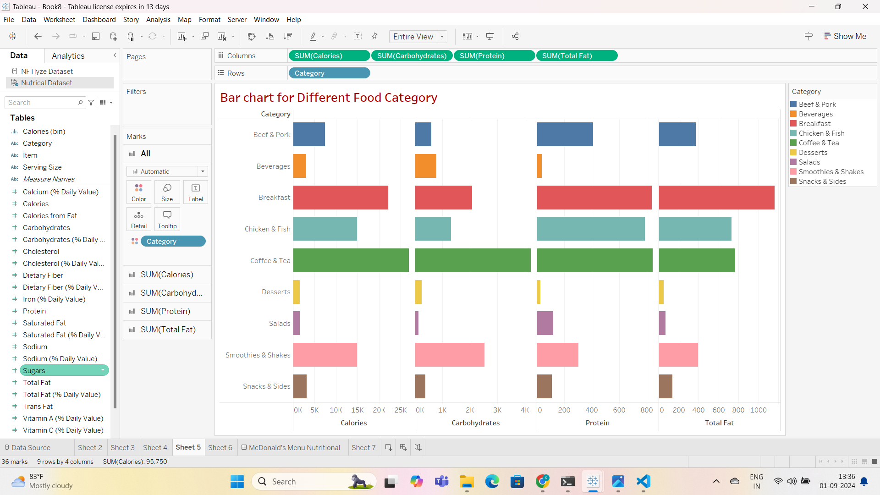

**Box plot for Nutritional Content**

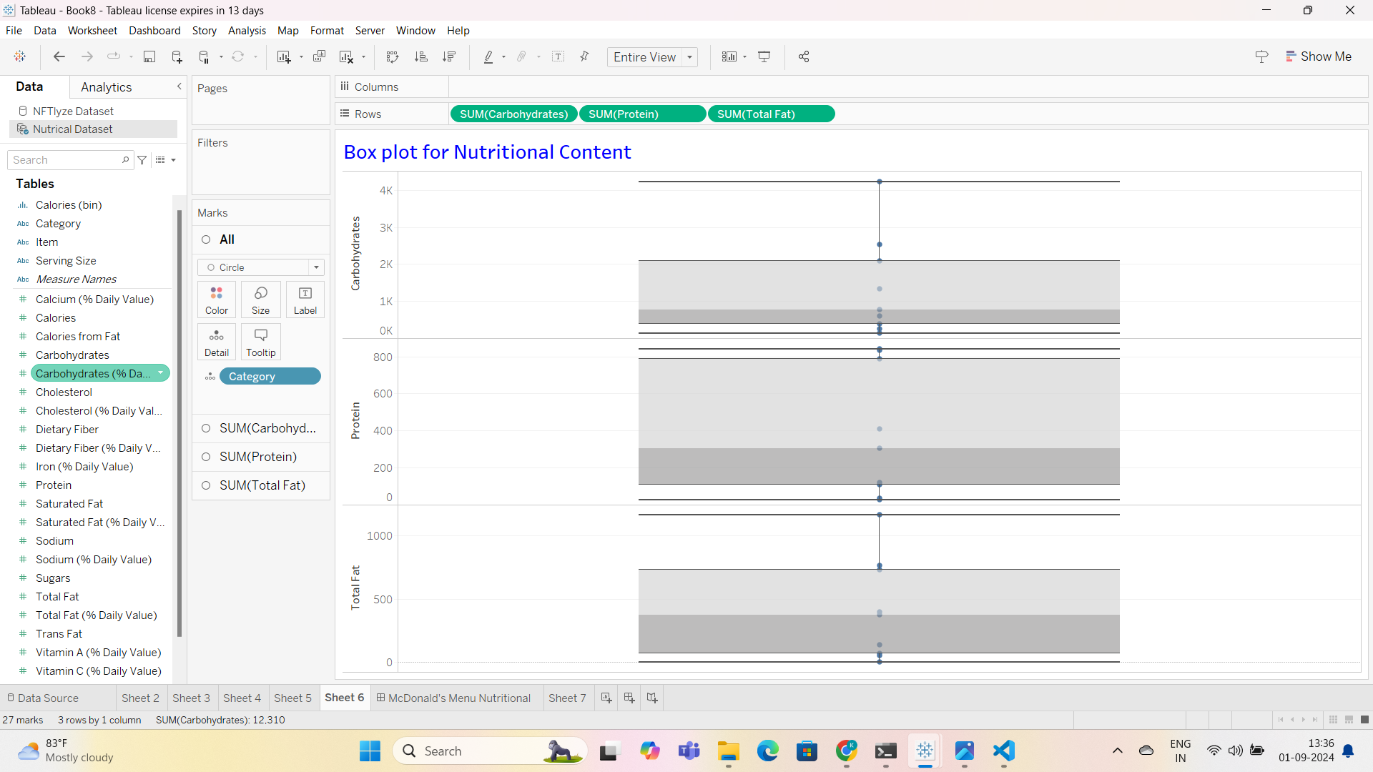

**Show Final Dashboard**

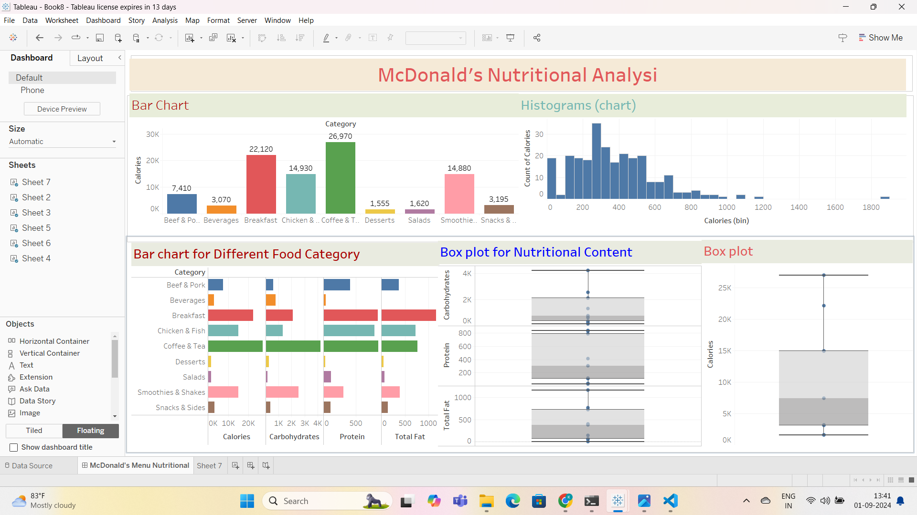

**Summary of Findings and Insights:**

1. **Calorie Distribution**: The analysis shows a wide range of calorie content across different food items. Some categories, like burgers and desserts, have higher calorie counts, while salads and drinks tend to have fewer calories.
2. **Nutritional Differences**: There are significant differences in nutritional content (like protein, fat, carbohydrates) between different food categories. For example, burgers are higher in protein and fat, while salads are rich in fiber and vitamins.
3. **Calorie Contribution**: Most of the calories come from items with high fat or sugar content, such as desserts and fried foods.

**Benefits of Nutritional Analysis:**

1. **For McDonald’s Customers**:
   * **Healthier Choices**: Customers can make better food choices based on their dietary needs or preferences, like selecting low-calorie or high-protein options.
   * **Transparency**: Provides clear nutritional information, helping customers understand the content of their meals.
2. **For McDonald’s Organization**:
   * **Customer Satisfaction**: Offering healthier options and transparent information can build trust and increase customer satisfaction.
   * **Market Positioning**: Helps McDonald's position itself as a brand that cares about customer health, which could attract health-conscious customers.
   * **Product Development**: Insights from the analysis can guide the development of new menu items that are healthier or cater to specific dietary needs.